Matches & Challenges
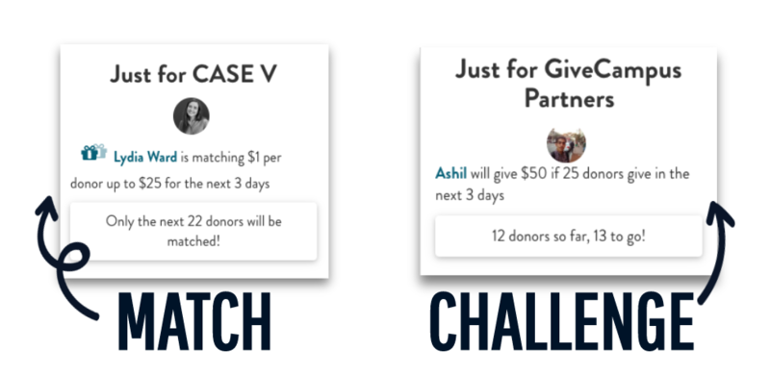

The first way to become an Advocate is to supercharge your own gift by offering a Match or Challenge.
Making a regular donation via the ‘Give Now’ button is quick and easy, and I definitely encourage you to check out the giving form so that you can share with others just how simple giving on GiveCampus is. But just making a regular donation won't make you an Advocate.
However, offering a Match or Challenge will earn you a spot on the Advocates list, because these features help take your gift the extra mile and inspire others to give.
- A Matching gift means that you’ll match a dollar amount for every donor who gives or every dollar given, up to your specific maximum amount.
- A Challenge gift means that you’ll make a gift only after a certain number of donors give or a certain number of dollars are given.
Both matches and challenges can be restricted, which means that you can configure your match or challenge to only apply to other donors from a class year or affiliation group, other donors who are supporting the same designation as you, or even a specific list of friends by email address.

You can set up your match or challenge before our official start date, April 7, which will allow other community members to see them as soon as the campaign launches!

