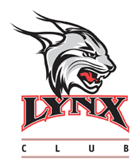
2017-2018 RHODES COLLEGE LYNX CLUB
I would like to designate my gift of $_______ to the _______________________ program.
Checks should be payable to Rhodes College. All gifts are tax-deductible and eligible for Lynx Club benefits and premiums. For more information or to make a credit card gift:
https://www.rhodes.edu/content/lynx-club-athletics
____ Yes. I request Lynx Club Premiums. If applicable, please choose apparel size below

S M L XL XXL

Name:
Address:
City: ST: Zip:
Please return form and checks to:
Jim Duncan
Director of Athletic Giving
Rhodes College – King Hall
2000 N. Parkway
Memphis, TN 38112

