Rhodes specific CSA information and resources
In 1990, Congress approved the Crime Awareness and Campus Security Act. Later renamed in Jeanne’s memory, the Jeanne Clery Act took effect in 1991. It requires that colleges and universities:
- Keep a public crime log
- publish an annual security report that includes crime statistics and security policies
• provide timely warnings to students and campus employees about a crime posing an immediate or ongoing threat to students and campus employees
• ensure certain basic rights for victims of sexual assault, dating violence, domestic violence, and stalking
The U.S. Department of Education enforces the Clery Act, and is responsible for collecting and disseminating crime statistics from colleges and universities each year.
Clery ACT Crime Definitions-
Homicide | - Murder/non-negligent manslaughter: the willful (non-negligent) killing of one human being by another
 | - Negligent Manslaughter: the killing of another person through gross negligence
Sex Offenses | - Sex offenses: Any sexual act directed against another person without the consent of the victim, including instances where the victim is incapable of giving consent  - Rape: The penetration, no matter how slight, of the vagina or anus with any body part or object, or oral penetration by a sex organ of another person, without the consent of the victim  - Fondling: The touching of the private body parts of another person for the purpose of sexual gratification, without the consent of the victim, including instances where the victim is incapable of giving consent because of his/her age or because of his/her temporary or permanent mental incapacity  - Incest: Sexual intercourse between persons who are related to each other within the degrees wherein marriage is prohibited by law  - Statutory Rape: Sexual intercourse with a person who is under the statutory age of consent
Robbery | Taking or attempting to take anything of value from the care, custody, or control of a person or persons by force or threat of force or violence and/or by putting the victim in fear
Aggravated Assault | Unlawful attack by one person upon another for the purpose of inflicting severe or aggravated bodily injury
Burglary | Unlawful entry of a structure to commit a felony or a theft
Motor Vehicle Theft | The theft or attempted theft of a motor vehicle
Arson | Willful or malicious burning or attempt to burn with or without intent to defraud a dwelling house, public building, motor vehicle or aircraft, personal property of another, etc.
Dating Violence | Violence committed by a person who is or has been in a social relationship of a romantic or intimate nature with the victim; and where the existence of such a relationship shall be determined based on a consideration of the following factors:  - the length of the relationship  - the type of the relationship  - the frequency of interaction between the persons involved in the relationship
Domestic Violence | Felony or misdemeanor crimes of violence committed by a current or former spouse or intimate partner of the victim, by a person with whom the victim shares a child in common, by a person who is cohabitating with or has cohabitated with the victim as a spouse or intimate partner, by a person similarly situated to a spouse of the victim under the domestic or family violence laws of the jurisdiction…or by any other person against an adult or youth victim who is protected from that person’s acts under the domestic or family violence laws of the jurisdiction
Stalking | Engaging in a course of conduct directed at a specific person that would cause a reasonable person to fear for his or her safety or the safety of others, or suffer substantial emotional distress
Liquor Law Violation | The violation of state or local laws or ordinances prohibiting the manufacture, sale, purchase, transportation, possession, or use of alcoholic beverages
Drug Law Violation | The violation of laws prohibiting the production, distribution and/or use of certain controlled substances and the equipment or devices utilized in their preparation and/or use
Illegal Weapons Possession | The violation of laws or ordinances prohibiting the manufacture, sale, purchase, transportation, possession, concealment, or use of firearms, cutting instruments, explosives, incendiary devices, or other deadly weapons
Hate Crimes- all the crimes above and • Larceny-theft
• Simple assault
• Intimidation
• Destruction/damage/vandalism of property
Is there any evidence that this crime was motivated by bias?
If yes, please choose any/all categories of prejudice that apply.

Race | ☐ | Ethnicity | ☐ | Disability | ☐ | Gender Identity | ☐
Gender | ☐ | Religion | ☐ | National Origin | ☐ | Sexual Orientation | ☐

If you answered “yes” to the Motivated by Bias question, please provide a brief summary of the evidence supporting a bias motivation:

Geography Definitions

On campus:
- any building or property owned or controlled by an institution within the same reasonably contiguous geographic area and used by the institution in direct support of, or in a manner related to, the institution’s educational purposes, including residence halls; and
- any building or property that is within or reasonably contiguous to the area identified in paragraph (1) of this definition, that is owned by the institution but controlled by another person, is frequently used by students, and supports institutional purposes (such as food or other retail vendors)

Non-campus building or property:
- any building or property owned or controlled by a student organization that is officially recognized by the institution; or
- any building or property owned or controlled by an institution that is used in direct support of, or in relation to, the institution’s educational purposes, is frequently used by students, and is not within the same reasonably contiguous geographic area of the institution

Public property:
- all public property, including thoroughfares, streets, sidewalks, and parking facilities, that is within the campus, or immediately adjacent to and accessible from the campus

Campus Map-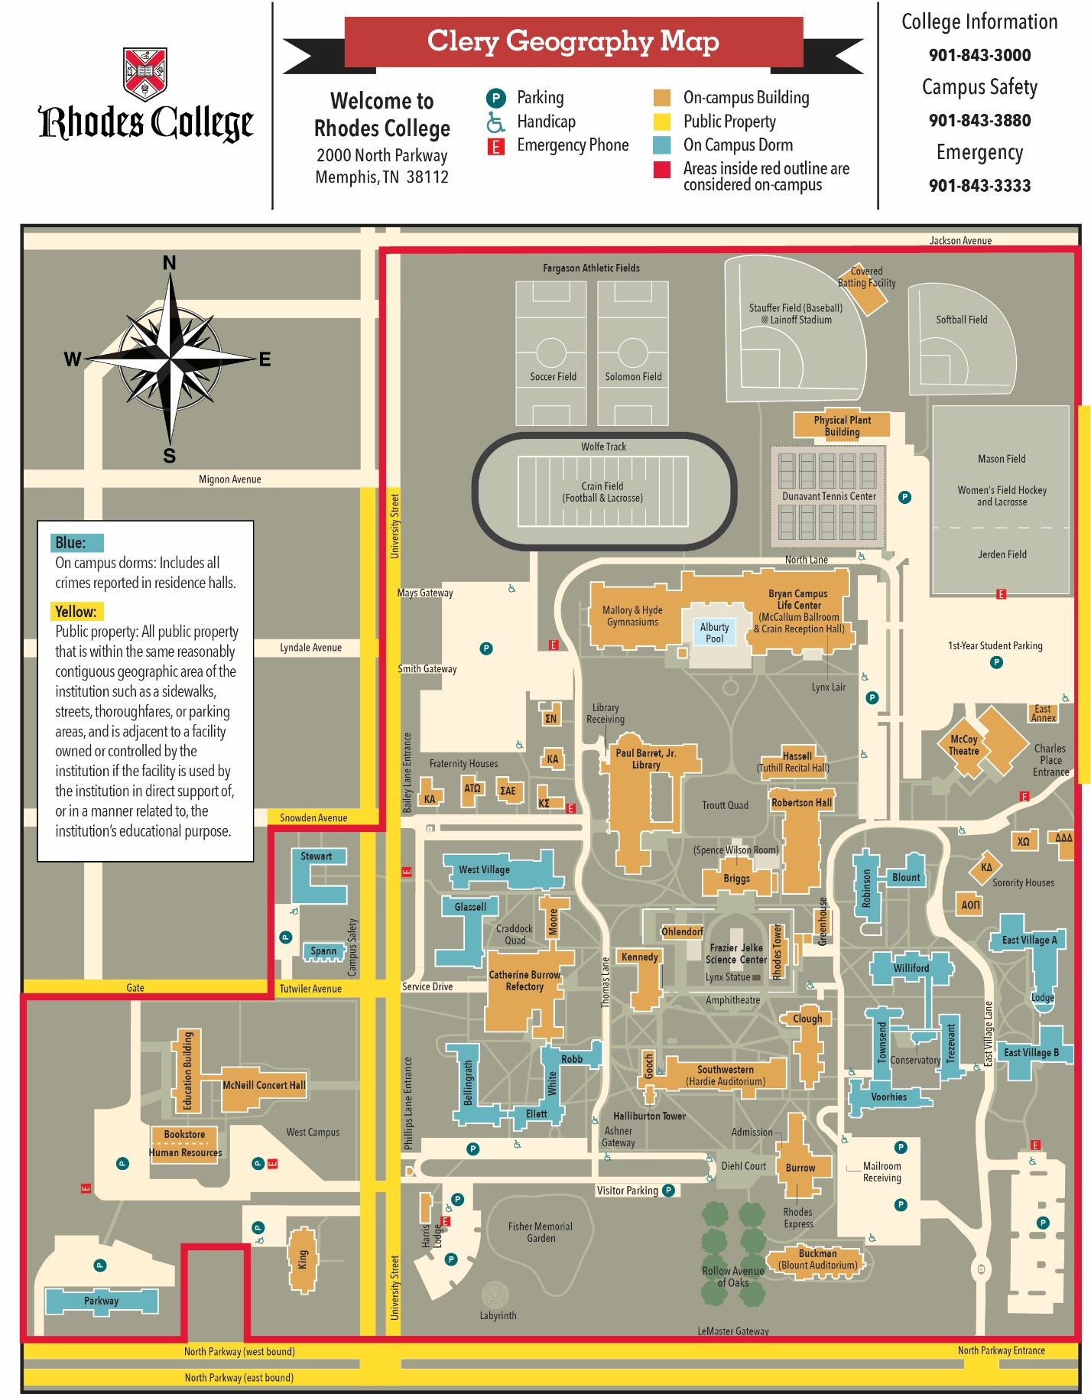

Additional resources:

Rhodes College Campus Safety is open 24/7 in Spann #5 to assist with any crime report. (901-843-3880)
Director of Campus Safety- Ike Sloas
Email -Sloasi@rhodes.edu or in person at Spann #5
Rhodes College Counseling Center
Email: counseling@rhodes.edu
Call: (901) 843-3128 (24/7)
Rhodes College Title IX and Title IX reporting
Inez Warner -Title IX Coordinator email warneri@rhodes.edu or calling the Title IX Office at 901-843-3550

